**Modulation** is the process of varying one or more parameters of a carrier signal in accordance with the instantaneous values of the message signal.

The message signal is the signal which is being transmitted for communication and the carrier signal is a high frequency signal which has no data, but is used for long distance transmission.

***Digital Modulation:*** is defined as changing the amplitude, frequency or phase (or some characteristics) of the carrier signal with respect to the modulating signal which is binary information or digital signal.

So, in analog modulation modulating signal is of analog nature and in digital modulation modulating signal is of digital nature.

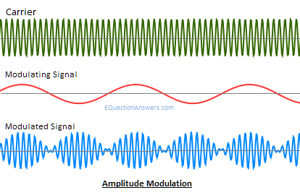

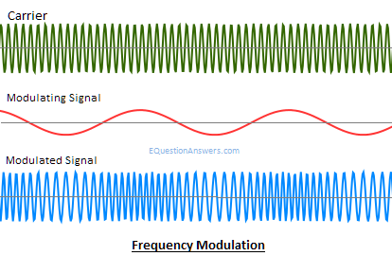

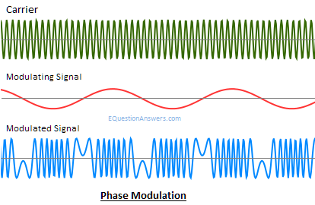

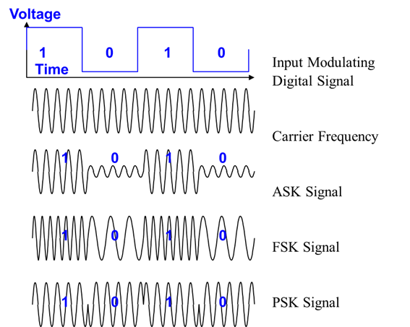

***Amplitude Shift Keying (ASK):*** is defined as changing the amplitude of the carrier signal with respect to the binary information or digital signal.

OR, the amplitude of the carrier wave is changed (switched) according to the digital input signal (modulating signal). Therefore, ASK is analogous to AM.

***Frequency Shift Keying (FSK):*** is defined as changing the frequency of the carrier signal with respect to the binary information or digital signal.

OR, if the frequency of the sinusoidal carrier wave is changed/varied (switched) depending on the digital input signal (modulating signal) then it is known as FSK. Therefore, FSK is analogous to FM.

***Phase Shift Keying (PSK):*** is defined as changing the phase of the carrier signal with respect to the binary information or digital signal.

OR, In PSK, phase of the carrier wave is switched according to the input digital signal. This is analogous to PM.

***Pulse Modulation:*** According to continuous Carrier Wave (CW) modulation, there is in direct contrast to pulse modulation.

In Pulse Modulation, some parameters of a pulse train is varied in accordance with the message signal.

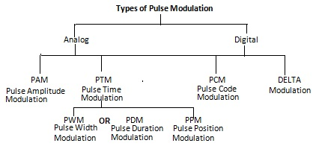

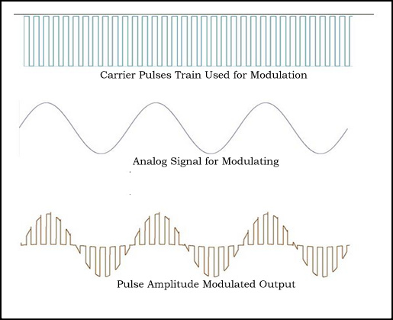

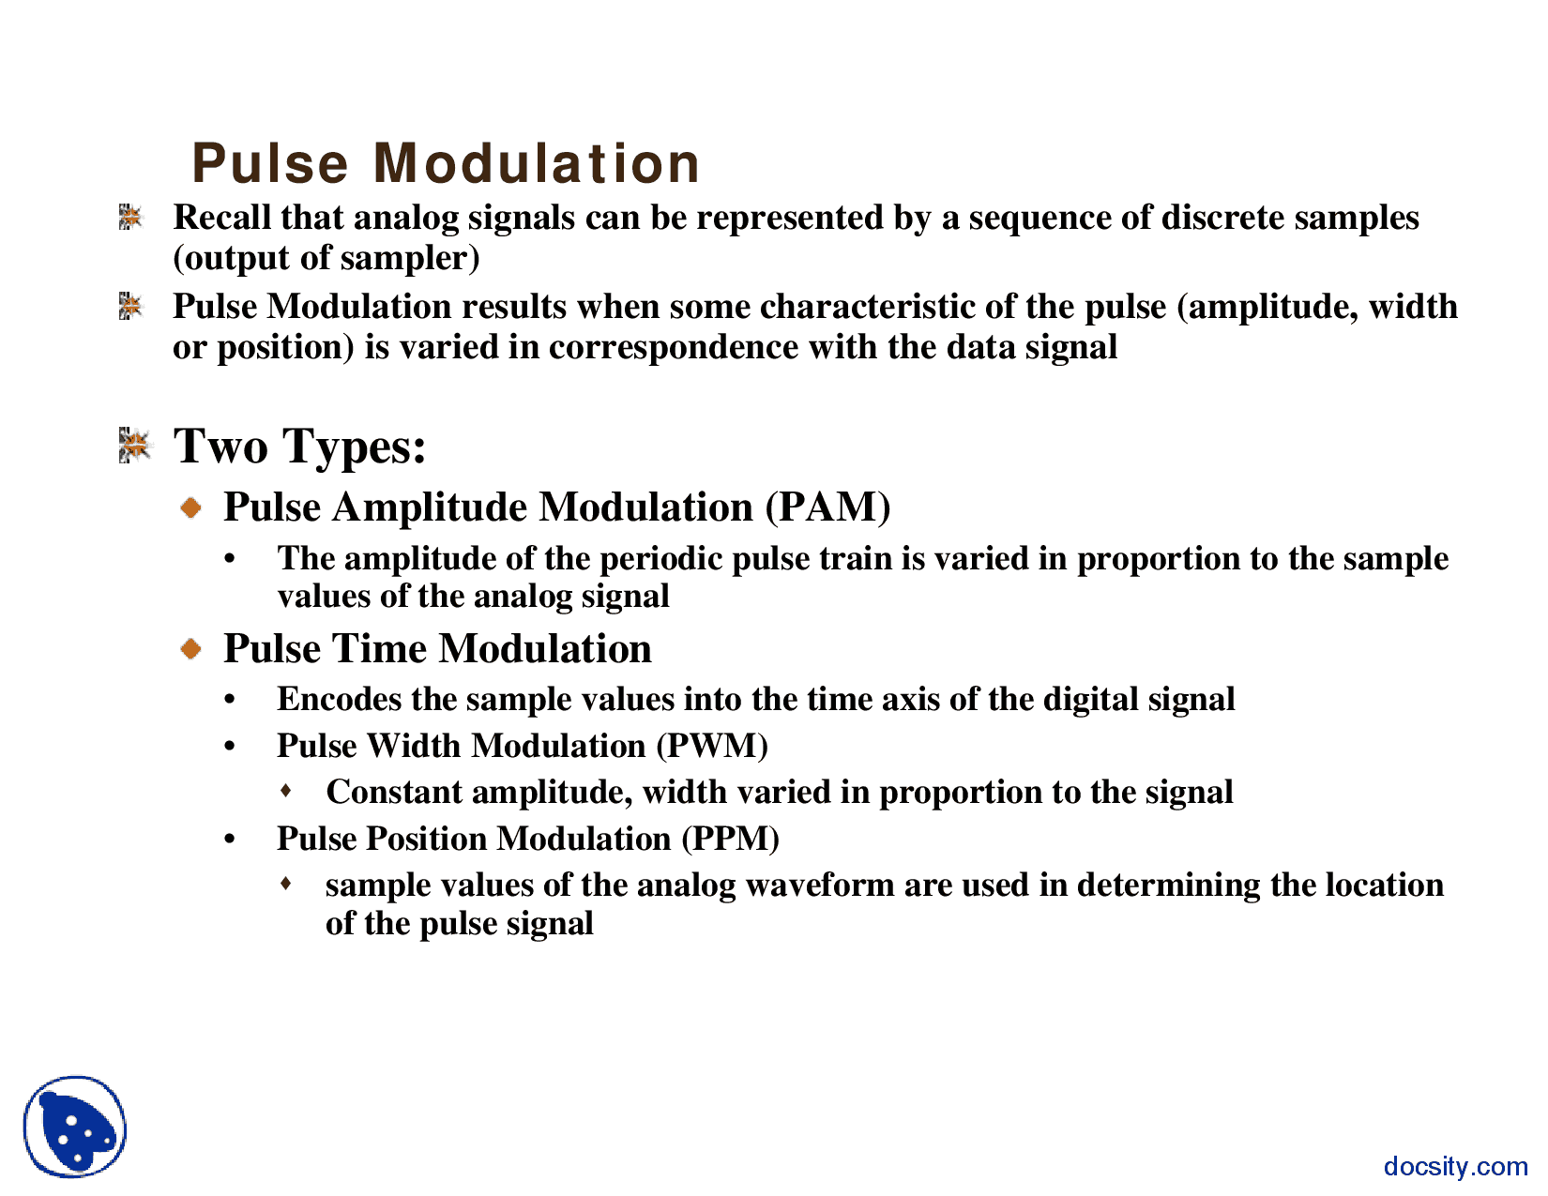

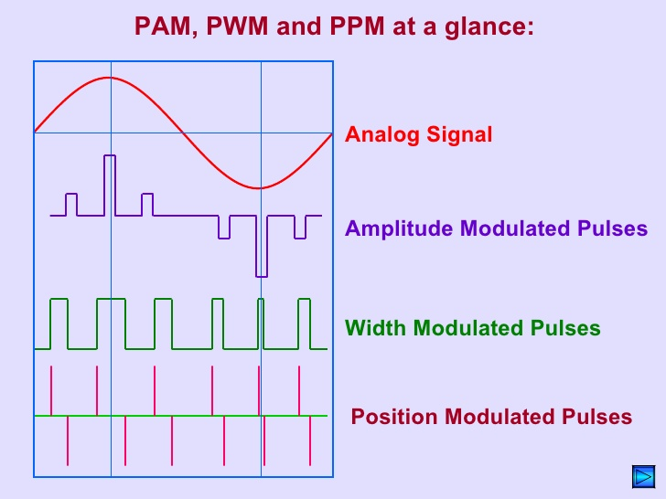

There are two families of pulse modulation:

1. Analog Pulse Modulation and
2. Digital Pulse Modulation
3. **Analog Pulse Modulation**: In analog pulse modulation, a periodic pulse train is used as the carrier wave, and some characteristics feature of each pulse (e.g., amplitude, duration or position) is varied in a continuous manner in accordance with the corresponding sample value of the message signal. Thus in analog pulse modulation, information is transmitted basically in analog form, but the transmission takes place as discrete times.
4. **Digital Pulse Modulation**: In digital pulse modulation, the message signal is represented in a form that is discrete in both time and amplitude, thereby permitting its transmission in digital form as a sequence of coded pulse, this form of signal transmission has no CW counterpart.

PCM:

There are many modulation techniques, which are classified according to the type of modulation employed. Of them all, the digital modulation technique used is **Pulse Code Modulation (PCM)**.

A signal is pulse code modulated to convert its analog information into a binary sequence, i.e., **1s** and **0s**. The output of a PCM will resemble a binary sequence. The following figure shows an example of PCM output with respect to instantaneous values of a given sine wave.

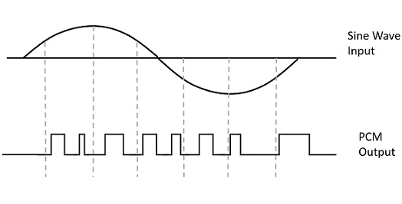

Instead of a pulse train, PCM produces a series of numbers or digits, and hence this process is called as **digital**. Each one of these digits, though in binary code, represents the approximate amplitude of the signal sample at that instant.

In Pulse Code Modulation, the message signal is represented by a sequence of coded pulses. This message signal is achieved by representing the signal in discrete form in both time and amplitude.

**Basic Elements of PCM**

The transmitter section of a Pulse Code Modulator circuit consists of **Sampling, Quantizing** and **Encoding**, which are performed in the analog-to-digital converter section. The low pass filter prior to sampling prevents aliasing of the message signal.

The basic operations in the receiver section are **regeneration of impaired signals, decoding,** and **reconstruction** of the quantized pulse train. Following is the block diagram of PCM which represents the basic elements of both the transmitter and the receiver sections.

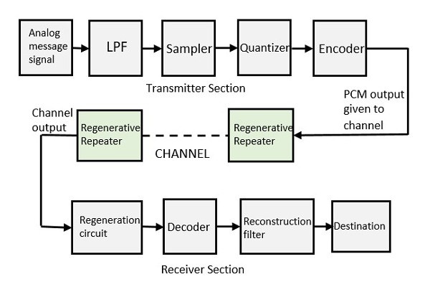

**Low Pass Filter**

This filter eliminates the high frequency components present in the input analog signal which is greater than the highest frequency of the message signal, to avoid aliasing of the message signal.

**Sampler**

This is the technique which helps to collect the sample data at instantaneous values of message signal, so as to reconstruct the original signal. The sampling rate must be greater than twice the highest frequency component **W** of the message signal, in accordance with the sampling theorem.

**Quantizer**

Quantizing is a process of reducing the excessive bits and confining the data. The sampled output when given to Quantizer, reduces the redundant bits and compresses the value.

**Encoder**

The digitization of analog signal is done by the encoder. It designates each quantized level by a binary code. The sampling done here is the sample-and-hold process. These three sections (LPF, Sampler, and Quantizer) will act as an analog to digital converter. Encoding minimizes the bandwidth used.

**Regenerative Repeater**

This section increases the signal strength. The output of the channel also has one regenerative repeater circuit, to compensate the signal loss and reconstruct the signal, and also to increase its strength.

**Decoder**

The decoder circuit decodes the pulse coded waveform to reproduce the original signal. This circuit acts as the demodulator.

**Reconstruction Filter**

After the digital-to-analog conversion is done by the regenerative circuit and the decoder, a low-pass filter is employed, called as the reconstruction filter to get back the original signal.

Hence, the Pulse Code Modulator circuit digitizes the given analog signal, codes it and samples it, and then transmits it in an analog form. This whole process is repeated in a reverse pattern to obtain the original signal.

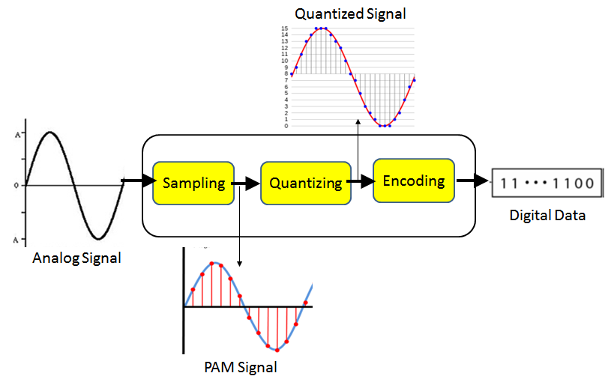

[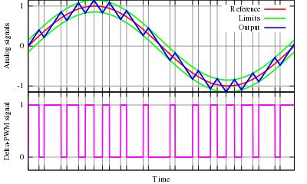](https://en.wikipedia.org/wiki/File:Delta_PWM.svg)

Principle of the delta PWM. The output signal (blue) is compared with the limits (green). The limits (green) correspond to the reference signal (red), offset by a given value. Every time the output signal reaches one of the limits, the PWM signal changes state.

**A delta modulation (DM or Δ-modulation**) is an [analog-to-digital](https://en.wikipedia.org/wiki/Analog-to-digital_converter) and [digital-to-analog signal](https://en.wikipedia.org/wiki/Digital-to-analog_converter) conversion technique used for transmission of voice information where quality is not of primary importance. DM is the simplest form of [differential pulse-code modulation](https://en.wikipedia.org/wiki/Differential_pulse-code_modulation) (DPCM) where the difference between successive samples are encoded into n-bit data streams. In delta modulation, the transmitted data are reduced to a 1-bit data stream. Its main features are:

* The analog signal is approximated with a series of segments.
* Each segment of the approximated signal is compared to the preceding bits and the successive bits are determined by this comparison.
* Only the change of [information](https://en.wikipedia.org/wiki/Information) is sent, that is, only an increase or decrease of the signal amplitude from the previous sample is sent whereas a no-change condition causes the modulated signal to remain at the same 0 or 1 state of the previous sample.

To achieve high [signal-to-noise ratio](https://en.wikipedia.org/wiki/Signal-to-noise_ratio), delta modulation must use [oversampling](https://en.wikipedia.org/wiki/Oversampling) techniques, that is, the analog signal is sampled at a rate several times higher than the [Nyquist rate](https://en.wikipedia.org/wiki/Nyquist_rate" \o "Nyquist rate).

Derived forms of delta [modulation](https://en.wikipedia.org/wiki/Modulation) are [continuously variable slope delta modulation](https://en.wikipedia.org/wiki/Continuously_variable_slope_delta_modulation), [delta-sigma modulation](https://en.wikipedia.org/wiki/Delta-sigma_modulation), and [differential modulation](https://en.wikipedia.org/w/index.php?title=Differential_modulation&action=edit&redlink=1). [Differential pulse-code modulation](https://en.wikipedia.org/wiki/Differential_pulse-code_modulation) is the superset of DM.

